Lab No 1: Date:
INTRODUCTION TO VERILOG
Objectives:
In this lab, student will be able to
- Learn the basic concepts of logic circuits and analyze the logic network.
- Write the Truth table and Timing diagram.
- Understand different representation of logic circuits in Verilog.
- Learn the different tools available in the CAD system.
- Write and simulate logic circuits using Verilog.

- Basic concepts of Logic Circuits
Logic Circuits
- Perform operations on digital signals.
- Signal values are restricted to a few discrete values.
- In binary logic circuits, there are only two values, 0 and 1.
Logic Gates and Networks
- Each logic operation can be implemented electronically with transistors, resulting in a circuit element called a logic gate.
- It has one or more inputs and one output that is a function of its inputs.
- It is often convenient to describe a logic circuit by drawing a circuit diagram, or schematic, consisting of graphical symbols representing the logic gates.
The graphical symbols for the AND, NOT and OR gates are shown in Fig. 1.1, 1.2 and 1.3 respectively.
Figure 1.1 Figure 1.2
Figure 1.3
- A larger circuit is implemented by a network of gates, as shown in Fig. 1.4

Figure 1.4
- The operations AND, OR etc can also be defined in the form of a table as shown in Figure 1.5.
- The first two columns (to the left of the heavy vertical line) give all four possible combinations of logic values that the variables x1 and x2 can have.
- The next column defines the AND operation for each combination of values of x1 and x2, and the last column defines the OR operation.
- In general, for n input variables the truth table has 2^{n} rows.
Figure 1.5 Truth Table
- Analysis of a Logic Network
- Determining the function performed by an existing logic network is referred to as the Analysis process.
- The reverse task of designing a new network that implements a desired functional behavior is referred to as the Synthesis process.
- To determine the functional behavior of the network in Fig. 1.6, we can consider what happens if we apply all possible values to input signals x1 and x2. The analysis of these input values at various intermediate points is shown in Fig. 1.7.
Figure 1.6
x1 | x2 | A | B | f
0 | 0 | 1 | 0 | 1
0 | 1 | 1 | 0 | 1
1 | 0 | 0 | 0 | 0
1 | 1 | 0 | 1 | 1
Figure 1.7
Timing Diagram
- The information in Fig. 1.7 can be presented in graphical form, known as a timing diagram, as shown in Fig. 1.8.
- The figure shows the waveforms for the inputs and output of the network, as well as for the internal signals at the points labeled A and B.
Figure 1.8
Functionally Equivalent Networks
- Going through the same analysis procedure, we find that the output ‘g’ in Fig. 1.9, changes in exactly the same way as f does in Fig. 1.6.
- Therefore, g(x1, x2) = f (x1, x2), which indicates that the two networks are functionally equivalent.

Figure 1.9
- Introduction to CAD Tools
- Logic circuits are designed using CAD tools that automatically implement synthesis techniques.
- CAD system includes tools for design entry, synthesis and optimization, simulation and physical design.

Design Entry
- The starting point in the process of designing a logic circuit is the conception of what the circuit is supposed to do and the formulation of its general structure.
- The first stage of this process involves entering into the CAD system a description of the circuit being designed. This stage is called design entry.
- For design entry, we are writing source code in a hardware description language.

Hardware Description Languages
- A hardware description language (HDL) is similar to a typical computer programming language except that an HDL is used to describe hardware rather than a program to be executed on a computer.
- Two HDLs are IEEE standards: Verilog HDL and VHDL.

Why use Verilog
- Supported by most companies that offer digital hardware technology.
- Verilog provides design portability. A circuit specified in Verilog can be implemented in different types of chips and with CAD tools provided by different companies, without changing the Verilog specification.
- Both small and large logic circuit designs can be efficiently represented in Verilog code.

Functional Simulation
- The functional simulator tool verifies that the designed circuit functions as expected.
- It uses two types of information.
- First, the user’s initial design is represented by the logic equations generated during synthesis.
- Second, the user specifies the valuations of the circuit’s inputs that should be applied to these equations during the simulation.
- For each valuation, the simulator evaluates the outputs produced by the expressions.
- The results of simulations are usually provided in the form of a timing diagram that the user can examine to verify that the circuit operates as required.
Timing Simulation
- When the values of inputs to the circuit change it takes a certain amount of time before a corresponding change occurs at the output. This is called a propagation delay of the circuit.

- Representation of Digital Circuits in Verilog
- Structural representation- A larger circuit is defined by writing code that connects simple circuit elements together.
- Behavioral representation- Describing a circuit by using logical expressions and programming constructs that define the behavior of the circuit but not its actual structure in terms of gates.
Structural Specification of Logic Circuits
- A gate is represented by indicating its functional name, output, and inputs. Different logic gates are shown in Table 1.1
For example,
- A two-input AND gate, with inputs x1 and x2 and output y, is denoted as
and (y, x1, x2);
- A four-input OR gate is specified as
or (y, x1, x2, x3, x4);
- The NOT gate is given by not (y, x); implements y = x’.
Table 1.1
Verilog Module
- It is a circuit or subcircuit described with Verilog code.
- The module has a name, module_name, which can be any valid identifier, followed by a list of ports.
- The term port refers to an input or output connection in an electrical circuit. The ports can be of type input, output, or inout (bidirectional), and can be either scalar or vector.

The General Form of a Module
module module name [(port name{, port name})];
[parameter declarations]
[input declarations]
[output declarations]
[inout declarations]
[wire or tri declarations]
[reg or integer declarations]
[function or task declarations]
[assign continuous assignments]
[initial block]
[always blocks]
[gate instantiations]
[module instantiations]
endmodule

Documentation in Verilog Code
- Documentation can be included in Verilog code by writing a comment. A short comment begins with the double slash, //, and continues to the end of the line. A long comment can span multiple lines and is contained inside the delimiters /* and */.
White Space
- White space characters, such as SPACE and TAB, and blank lines are ignored by the Verilog compiler.
- Multiple statements can be written on a single line.
- Placing each statement on a separate line and using indentation within blocks of code, such as an if-else statement are good ways to increase the readability of code.
Signals in Verilog Code
- A signal in a circuit is represented as a net or a variable with a specific type.
- A net or variable declaration has the form
type [range] signal_name{, signal_name};
- The signal_name is an identifier
- The range is used to specify vectors that correspond to multi-bit signals
Signal Values and Numbers
- Verilog supports scalar nets and variables that represent individual signals and vectors that correspond to multiple signals.
- Each individual signal can have four possible values:
0 = logic value 0 1 = logic value 1
z = tri-state (high impedance) x = unknown value
- The value of a vector variable is specified by giving a constant of the form [size][’radix]constant where size is the number of bits in the constant, and radix is the number base. Supported radices are
d = decimal b = binary h = hexadecimal o = octal
- Some examples of constants include
0 the number 0 10 the decimal number 10
’b10 the binary number 10 = (2)₁₀ ’h10 the hex number 10 = (16)₁₀
4’b100 the binary number 0100 = (4)₁₀

Nets
Verilog defines a number of types of nets.
- A net represents a node in a circuit.
- For synthesis purposes, the only important nets are of wire type.
- For specifying signals that are neither inputs nor outputs of a module, which are used only for internal connections within the module, Verilog provides the wire type.

Identifier Names
- Identifiers are the names of variables and other elements in Verilog code.
- The rules for specifying identifiers are simple: any letter or digit may be used, as well as the _ underscore and $ characters.
- An identifier must not begin with a digit and it should not be a Verilog keyword.
- Examples of legal identifiers are f, x1, x, y, and Byte.
- Some examples of illegal names are 1x, +y, x*y, and 258
- Verilog is case sensitive, hence k is not the same as K, and BYTE is not the same as Byte.

Verilog Operators
- Verilog operators are useful for synthesizing logic circuits.
- Table 1.2 lists these operators in groups that reflect the type of operation performed.

Table 1.2
Operator type | Operator Symbols | Operation Performed | Number of operands
Bitwise | ~  &  |  ^  ~^ or ^~ | 1’s complement  Bitwise AND  Bitwise OR  Bitwise XOR  Bitwise XNOR | 1  2  2  2  2
Logical | !  &&  || | NOT  AND  OR | 1  2  2
Reduction | &  ~&  |  ~|  ^  ~^ or ^~ | Reduction AND  Reduction NAND  Reduction OR  Reduction NOR  Reduction XOR  Reduction XNOR | 1  1  1  1  1  1
Arithmetic | +  -  -  *  / | Addition  Subtraction  2’s complement  Multiplication  Division | 2  2  1  2  2
Relational | >  <  >=  <= | Greater than  Lesser than  Greater than or equal to  Lesser than or equal to | 2  2  2  2
Equality | ==  != | Logical equality  Logical inequality | 2  2
Shift | >>  << | Right shift  Left shift | 2  2
Concatenation | {,} | Concatenation | Any number
Replication | {{}} | Replication | Any number
Conditional | ?: | Conditional | 3

SAMPLE LAB OBSERVATION NOTE PREPARATION
LAB NO: Date:
Title: Introduction to Verilog
- Write Verilog code to implement the following circuit using the continuous assignment.
Aim: To write Verilog code, Testbench code, Truth table, and waveform for the above circuit.
Verilog code:
module example1(x1, x2, x3, f);
input x1, x2, x3;
output f;
assign f = (x1 & x2) | (~x2 & x3);
endmodule
TestBench Code:
`timescale 1ns/1ns
`include "example1.v" //Name of the Verilog file

module example1_tb();
reg x1, x2, x3; //Input
wire f; //Output

example1 ex1(x1, x2, x3, f); //Instantiation of the module
initial
begin

$dumpfile("example1_tb.vcd");
$dumpvars(0, example1_tb);

x1=1'b0; x2=1'b0; x3=1'b0;
#20;

x1=1'b0; x2=1'b0; x3=1'b1;
#20;

x1=1'b0; x2=1'b1; x3=1'b0;
#20;

x1=1'b0; x2=1'b1; x3=1'b1;
#20;

x1=1'b1; x2=1'b0; x3=1'b0;
#20;

x1=1'b1; x2=1'b0; x3=1'b1;
#20;

x1=1'b1; x2=1'b1; x3=1'b0;
#20;

x1=1'b1; x2=1'b1; x3=1'b1;
#20;

$display("Test complete");
end

endmodule

Truth table:
x1 | x2 | x3 | F
0 | 0 | 0 | 0
0 | 0 | 1 | 1
0 | 1 | 0 | 0
0 | 1 | 1 | 0
1 | 0 | 0 | 0
1 | 0 | 1 | 1
1 | 1 | 0 | 1
1 | 1 | 1 | 1

Waveform:
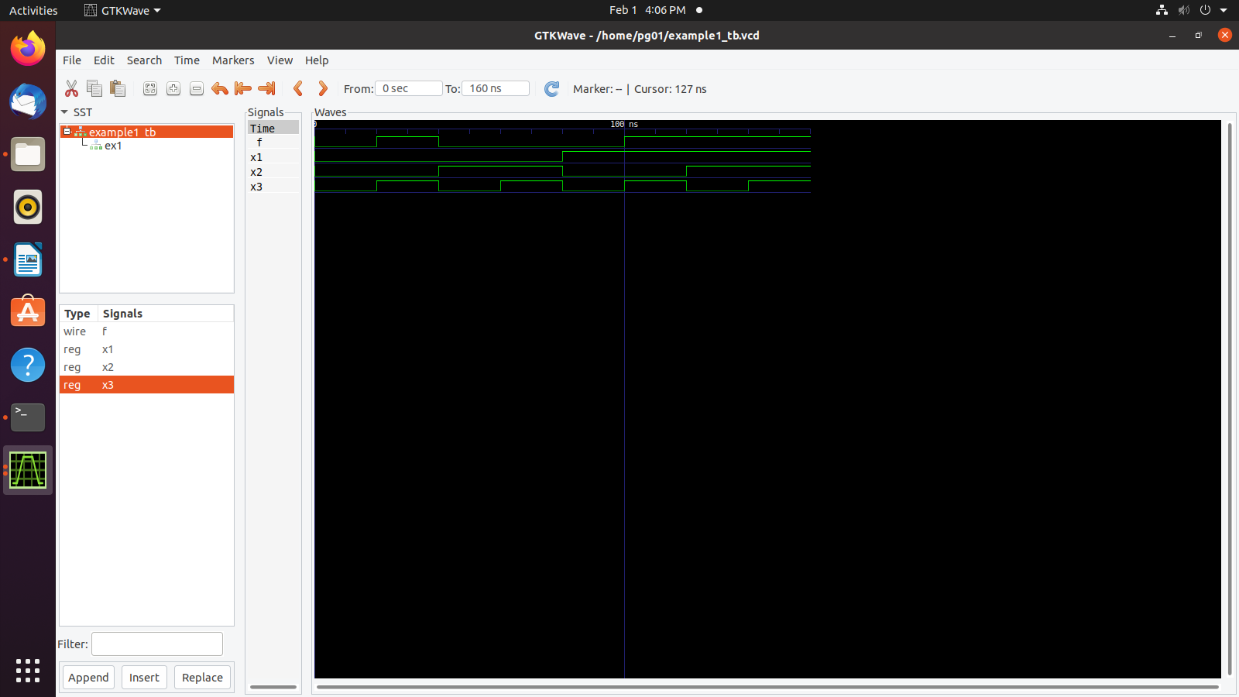

Running a sample Verilog code
Let us look at a Verilog implementation in the following steps:
- Create a directory with section followed by roll number (to be unique); e.g. A21
- Open any text editor in Ubuntu (say, gedit) and type the source code.

module example2(x1, x2, x3, f);
input x1, x2, x3;
output f;
and (g, x1, x2);
not (k, x2);
and (h, k, x3);
or (f, g, h);
endmodule

- Save the source code with file name same as module name but with ‘.v’ extension in the required directory.
- Type the following testbench code.
`timescale 1ns/1ns
`include "example2.v" //Name of the Verilog file

module example2_tb();
reg x1, x2, x3; //Input
wire f; //Output

example2 ex2(x1, x2, x3, f); //Instantiation of the module
initial
begin

$dumpfile("example2_tb.vcd");
$dumpvars(0, example2_tb);

x1=1'b0; x2=1'b0; x3=1'b0;
#20;

x1=1'b0; x2=1'b0; x3=1'b1;
#20;

x1=1'b0; x2=1'b1; x3=1'b0;
#20;

x1=1'b0; x2=1'b1; x3=1'b1;
#20;

x1=1'b1; x2=1'b0; x3=1'b0;
#20;

x1=1'b1; x2=1'b0; x3=1'b1;
#20;

x1=1'b1; x2=1'b1; x3=1'b0;
#20;

x1=1'b1; x2=1'b1; x3=1'b1;
#20;

$display("Test complete");
end

endmodule
- Save the source code with file name same as module name but with ‘.v’ extension in the same directory.
- Go to the terminal. Type the following commands for compilation.
  - iverilog -o example2_tb.vvp example2_tb.v
On successful execution, file example2_tb.vvp is created.
  - vvp example2_tb.vvp
On successful execution, file example2_tb.vcd is created and the following messages are displayed in the terminal.
VCD info: dumpfile example2_tb.vcd opened for output.
Test complete

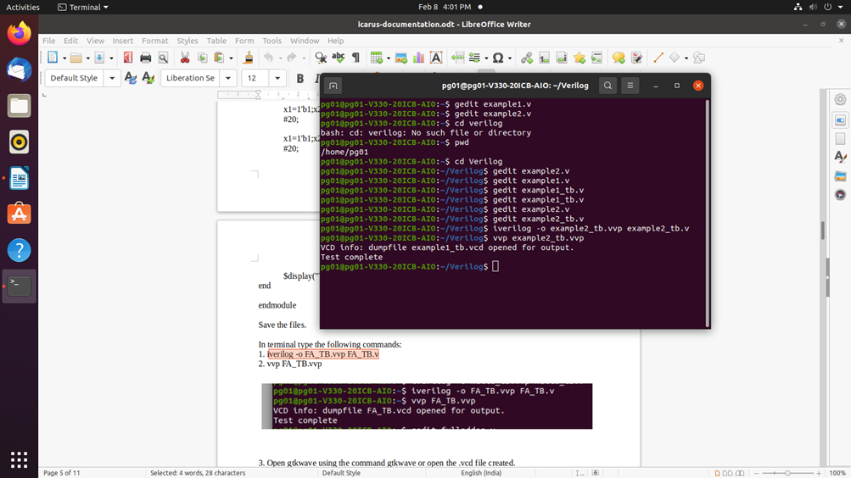

- Open gtkwave by double clicking the example2_tb.vcd file available in your directory or type gtkwave in the terminal and open the example2_tb.vcd file in gtkwave. A window appears as shown below.

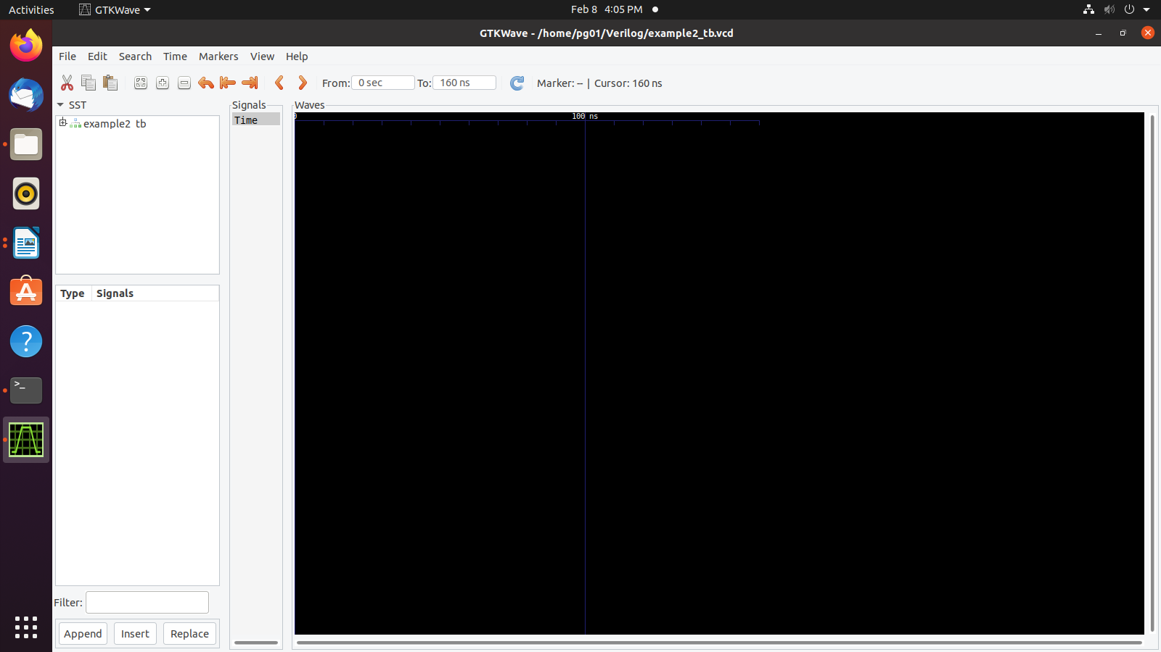

- Expand example2_tb that appears in the left pane. The screen appears as shown below. It can be observed that the input and output variables appear in the bottom left pane.
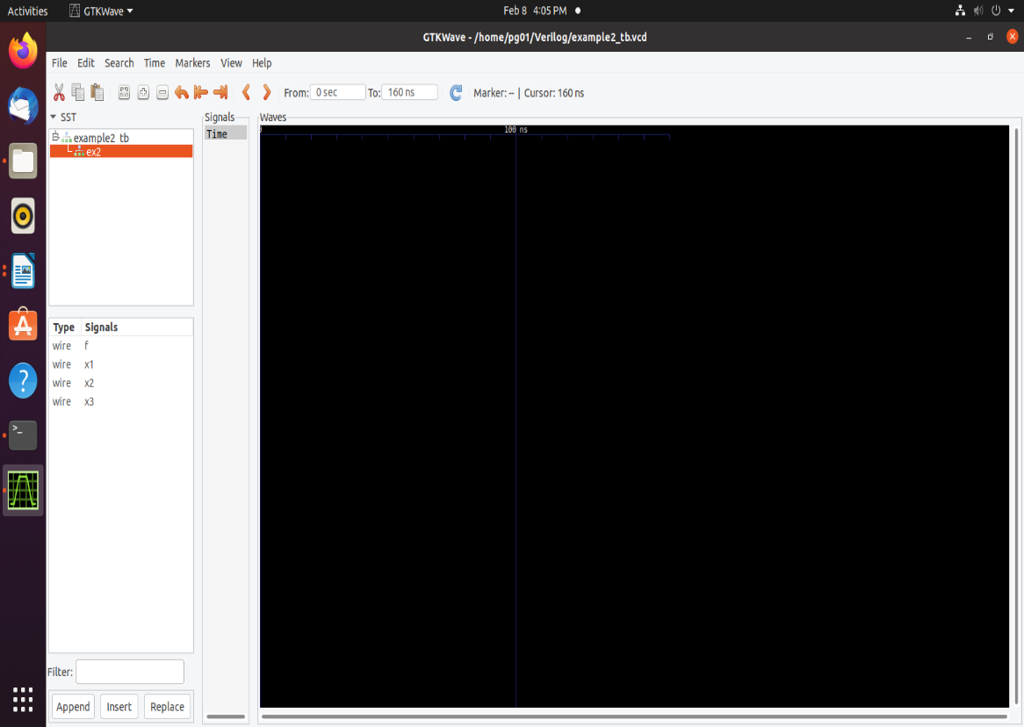

- Drag and drop the variables that appears in the Signals tab of the bottom left pane into Signals column that appears in the middle of the window. The output appears as shown below. Cross-verify the output with the truth table.

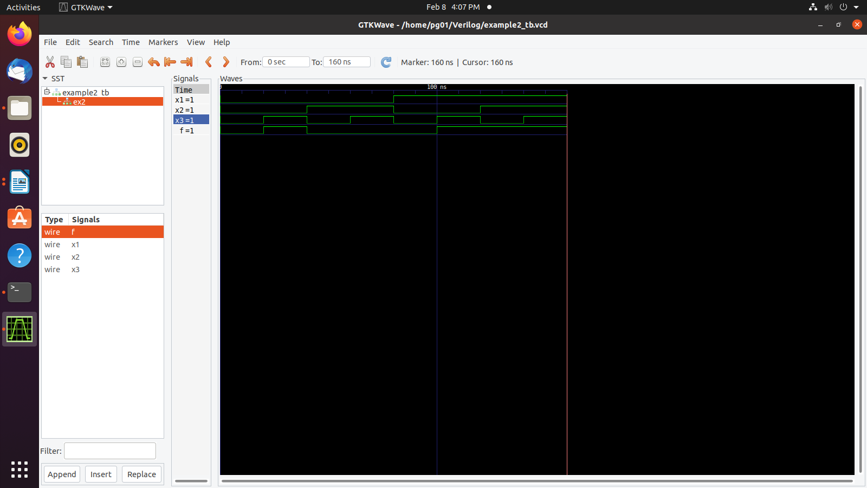

- Generated outputs are with respect to the values for input variables in the test bench.

- Behavioral Specification of Logic Circuits
- Gate level primitives can be tedious when large circuits have to be designed.
- Abstract expressions and programming constructs are used to describe the behavior of a digital circuit.
- To define the circuit using logic expressions. The AND and OR operations are indicated by the ‘&’ and ‘|’ signs, respectively.
- The assign keyword provides a continuous assignment for the output signal.
- Whenever any signal on the right-hand side changes its state, the value of output will be re-evaluated.
module example2 (x1, x2, x3, f);
input x1, x2, x3;
output f;
assign f = (x1 & x2) | (x2 & x3);
endmodule

Lab Exercises
- Write the Verilog code to implement the circuit in the following figure.
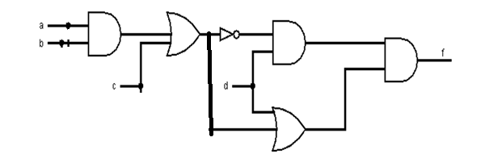

- Using gate-level primitives
- Using continuous assignment statements.

- Write the Verilog code to implement the circuit in the following figure.

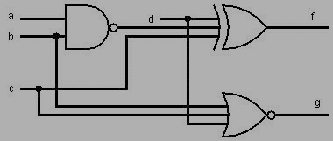
- Using gate-level primitives
- Using continuous assignment statements.
Additional Exercises
  - Write Verilog code to describe the following functions
f1 = ac’+ bc + b’c’
f2 = (a + b’ + c)(a + b + c’)(a’ + b + c’)
  - Check whether f1 and f2 in question 1 are functionally equivalent or not.

